If there is a problem printing from VRS then close VRS and go back to the “Citrix StoreFront” screen by logging back in, but do not yet click on the KY-Voter-Registration icon.  Please click on the gear icon in the top right corner of the screen:

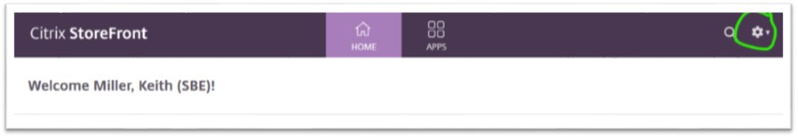

Then click “Account Settings”

Then click “Change Citrix Receiver”

Click “Detect Receiver”:

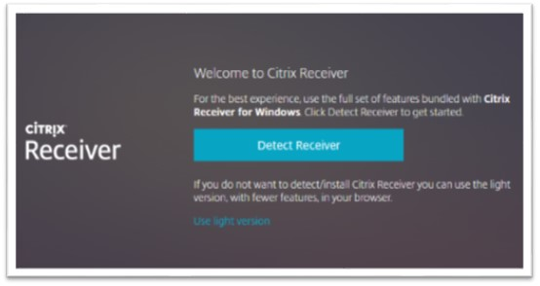

The screen may flash and take you back to the Citrix StoreFront.  Be sure to allow any permissions that may popup from Citrix or Workspace App.  You may now launch VRS by clicking the KY-Voter-Registration icon and try printing again.