**Search for tickets by County Name**

Searching for tickets by county is done easily enough as anytime a county is chosen in the creation of a ticket a tag with an underscore and the county name is automatically created. To search by county name simply input **_countyname** in the search field. For example, to search for Bullitt county you would input **_bullitt**

[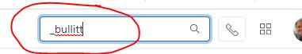](https://us-prod.asyncgw.teams.microsoft.com/v1/objects/0-cus-d16-283b47eec2b5d370d1da3f662b66bdfe/views/imgo)

**Search for ticket by County Name and Ticket Creation Date**

To search for a ticket by county and a specific date on which the ticket was created (or replace “created with “solved” to find solved) you would search created: thedate _countyname. For example, bullitt county tickets created on June 22 the search input would be **created:2021-06-22 _bullitt**

[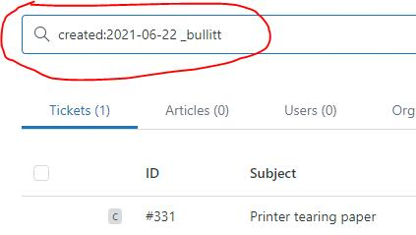](https://us-prod.asyncgw.teams.microsoft.com/v1/objects/0-cus-d7-98ffaba676f0a2082b3a19a4c52d8c59/views/imgo)

We can also do this by date range. For example: **created>2021-06-21 created<2021-06-28 _bullitt**

[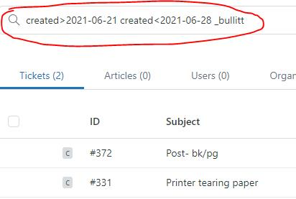](https://us-prod.asyncgw.teams.microsoft.com/v1/objects/0-cus-d4-0d37dc0347f3a5bff4a9973c5d9499c1/views/imgo)

**Search for ticket by County Name and Ticket Creation Date *and* Agent assigned ticket**

We can also add searching by whom was assigned the ticket. For example:

**assignee:Janet Lewis created>2021-06-21 created<2021-06-28 _bullitt**

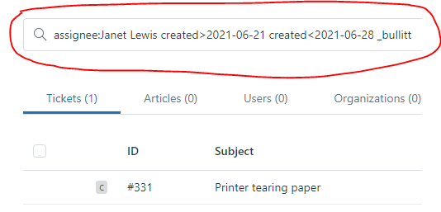

**Gabriel Hoskins**