When you are asking an end-user for their **first and the last name**, and **email address**, it is not just this information that Zendesk will save, but their **County** and **Phone number** as well.

1. Type the end users name and click **Add User.**

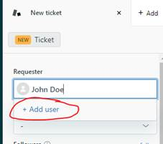

1. Add user name and email into the **Add new user** form

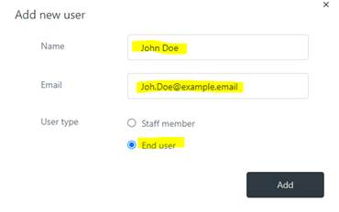

1. Click the tab with the end-user’s name and add county and phone number

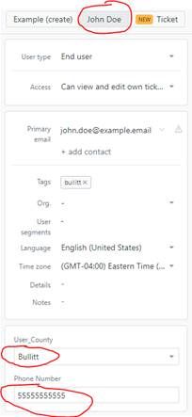

Now all of John Doe’s information is saved. The next time he opens a ticket his name will resolve as it is typed in the requester field…

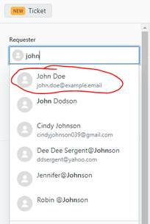

…and we can see all of the above info in steps 1-3, as well as his ticket history, simply by clicking his name tab.

