# Creating a Batch file to map the network drive G

## County with a File Server

Batch files are used to automatically map network drives each time a State machine is rebooted or started up in the morning. These batch files are *only* for state machines.

1. On a state computer, check if there is a .bat(batching) file on the computer using file path - C:\ProgramData\Microsoft\Windows\Start Menu\Programs\Startup. You can also use Windows + R and enter *shell:common startup*

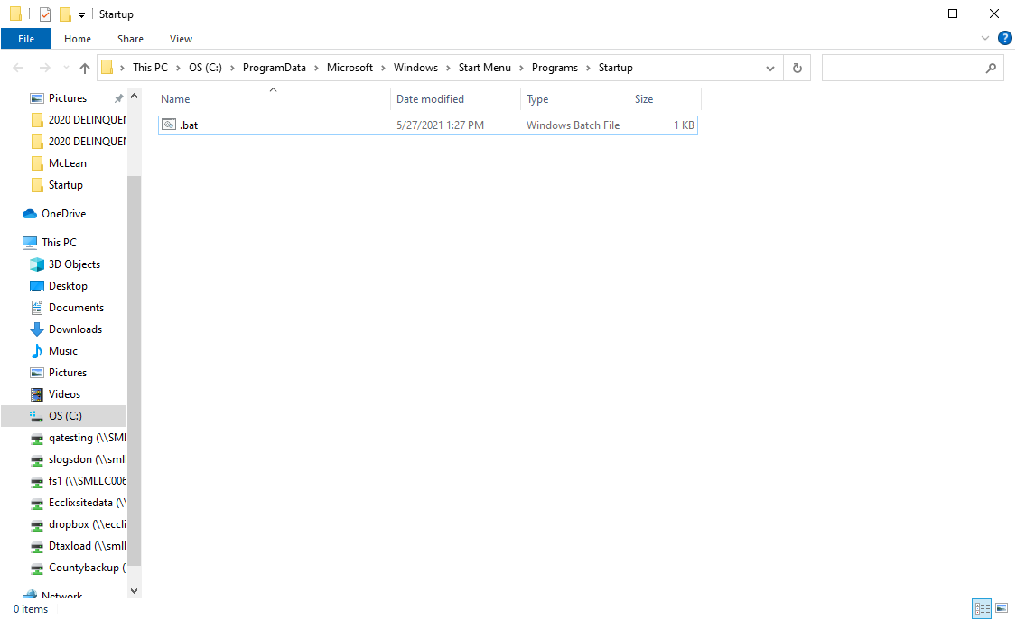

NOTE: If there is currently a batch file skip to step 3

1. If there is not currently a batch file on the State computer then open a blank notepad document.
2. Type the following commands into the notepad:

*@echo off*

*net use /delete \\10.65.#.93\fimage*

*netuse /delete G:*

*net use \\10.65.#.93\fimage /user:##clerk\deputy setup*

*net use G: \\10.65.#.93\DeputyShare /user:##clerk\deputy setup*

If there is already a batch file, right click on the file and select **Edit** to verify the information is correct. NOTE: # – County number or name

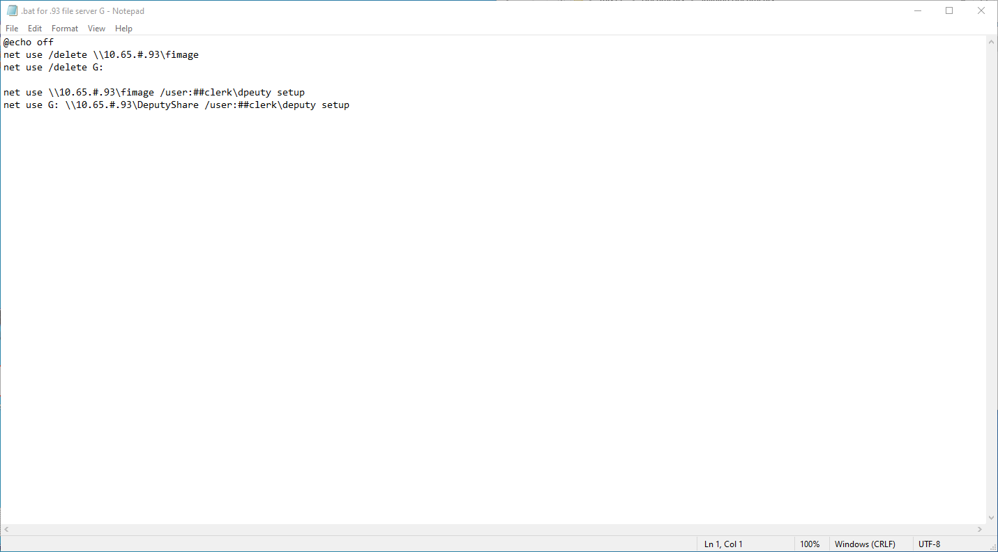

1. Click **File** and select **Save As.** Name the file *netuse.bat***,** choosing **All Files** as the file type. (Older machines may have the file saved as fimage.bat – moving forward when creating new file, save as netuse.bat)

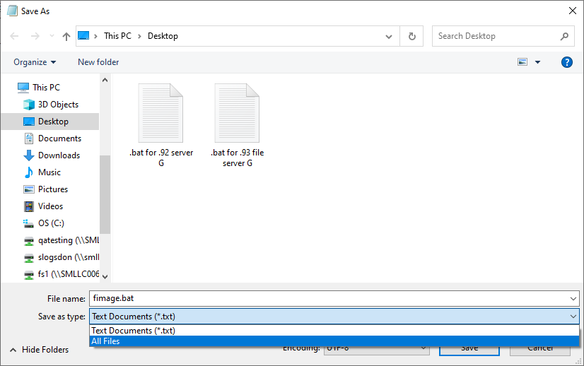

1. Save the .bat file in the startup folder at C:\ProgramData\Microsoft\Windows\Start Menu\Programs\StartUp



1. Double click and run the saved batch file. A black command prompt window will pop up and run through its process. Check to be sure that the DeputyShare (G:) drive has been mapped and is available.

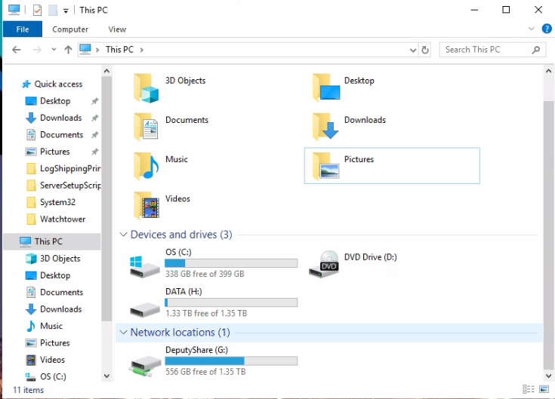

# Creating a Batch file to map the network drive F:

## County with a File Server

1. Check to see if there is a .bat(batching) file on the computer using file path - C:\ProgramData\Microsoft\Windows\Start Menu\Programs\Startup.

NOTE: If there is currently a batch file skip to step 3

1. If there is not currently a batch file on the State computer, open a blank notepad document.
2. Type the following commands into the notepad:

*@echo off*

*net use/delete F:*

*net use F: \\10.65.#.93\fimage /user:##clerk\deputy setup*

If there is already a batch file, right click on the file and select **Edit** to verify the information is correct. NOTE: # – County number or name

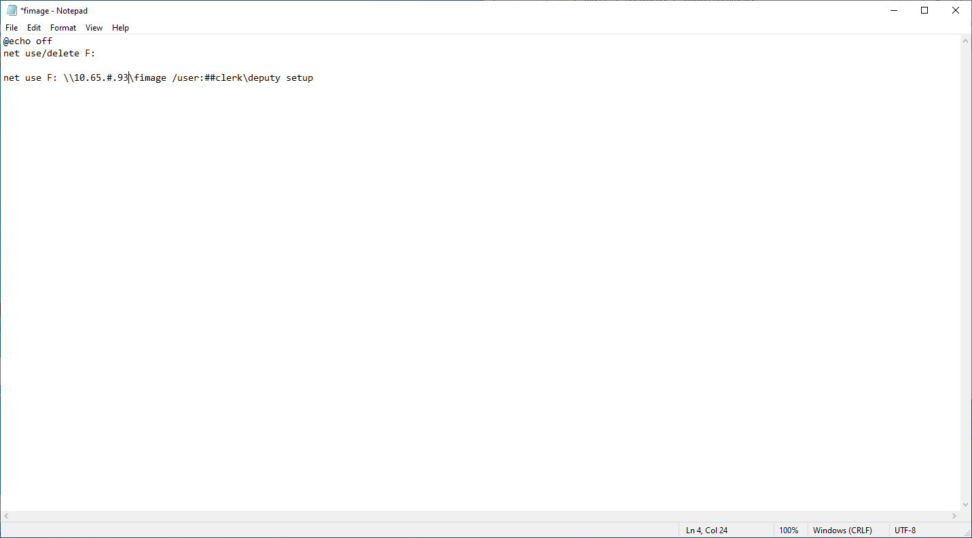

1. Click **File** and select **Save As.** Name the file *netuse.bat***,** choosing **All Files** as the file type. (Older machines may have the file saved as fimage.bat – moving forward when creating new file, save as netuse.bat)



1. Save the .bat file in the startup folder at C:\ProgramData\Microsoft\Windows\Start Menu\Programs\StartUp

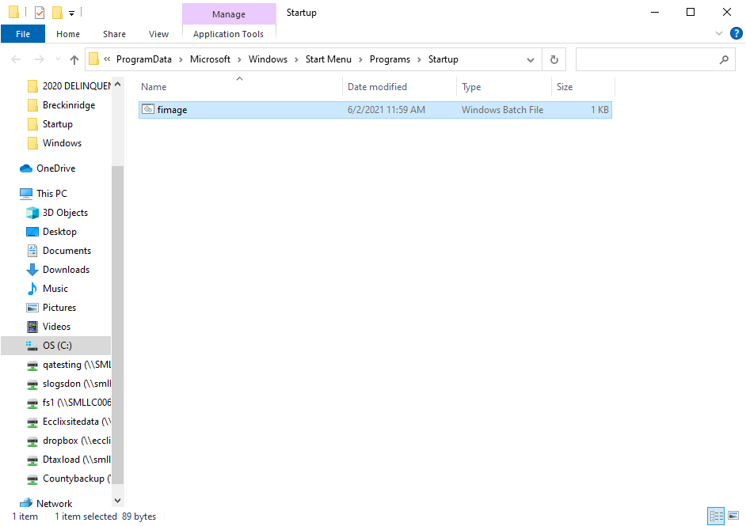

1. Double click and run the saved batch file. A black command prompt window will pop up and run through its process. Check to be sure Fimage (F:)drive has been mapped and is available.

