How to Download and Import Avis Files
- In the Avis Download screen, click Browse.
- Navigate to the folder where the Avis file is stored.
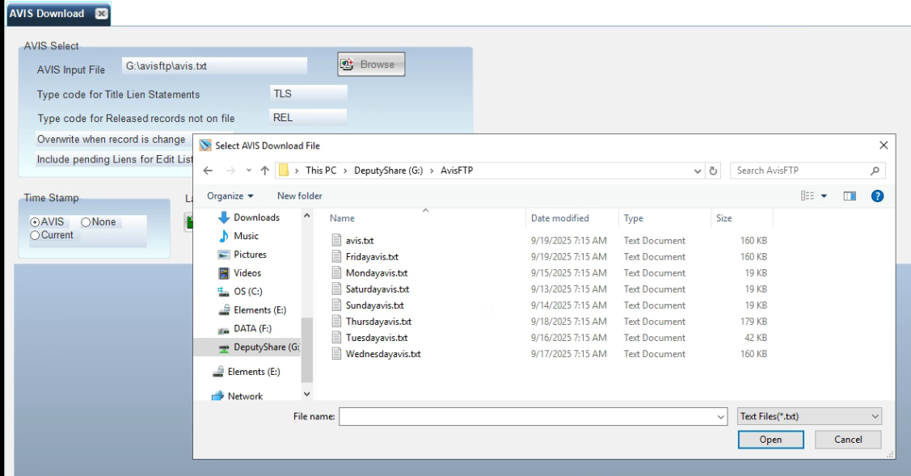

- Select the file for the date you want.
- Click Open.
- Return to the Avis Download screen and select Import.
➡️ Repeat these steps if you need to download and import files for another day of the week.

